**Writing and Citing with Academic Integrity**

**Ten Tips to Improve Your Writing**

1. Start early!
2. Read the assignment in the syllabus carefully and review the rubric if one is provided.
3. Locate academic—scholarly, peer-reviewed—sources. Use the library’s resources.
4. Take careful notes. Include the reference information with page numbers.
5. Spend time away from your research to process ideas.
6. Create a basic outline that includes the main points required in your paper. The main points will make logical headings in your paper.
   1. The introduction states your thesis and tells your reader why it is important and how you will support your claim. (“Explain what you will tell the reader.”)
   2. The body of your paper provides the evidence to support your claim. (“Tell the reader.”)
   3. Your conclusion summarizes the evidence and suggests key takeaways. (“Review what you told the reader.”)
7. Be clear, concise, and avoid complexity. Avoid jargon and define specialized terms.
8. Revise, revise, revise. Take time to refine your arguments.
9. Engage with and evaluate your research findings.
10. Seek feedback. Constructive criticism can improve your paper.

**Avoiding Plagiarism**

**Plagiarism is** **using another’s work** **without documenting the source**. Plagiarism applies to other people’s work as well as your own (e.g., lifting portions from a previous paper you have written without citing it). It also includes patchwriting, where the essence of the original work remains.

**Why Cite Sources?**

* To show readers that you have done your research.
* To give credit to others for the work they have done.
* To provide readers the ability to check your sources if there are questions.
* To point the way for others to build on your work.

**Citation Rules**

Pro tip: When in doubt, cite it. Give credit where credit is due. To avoid plagiarism, it is always better to err on the side of overciting than to undercite.

Provide a citation whenever:

1. Referring to or mentioning a source in general (e.g., a book/article title, entire chapter, whole website, etc.).

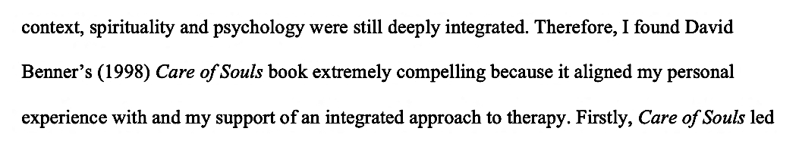

1. Quoting from a source (block quote or in text).

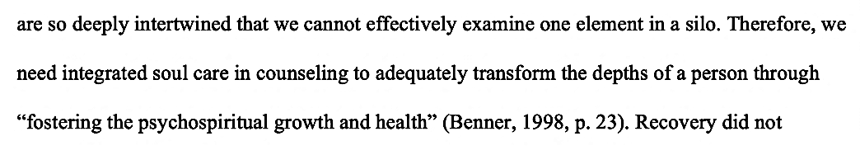

1. Paraphrasing or rewording a thought, concept, or idea from a source.

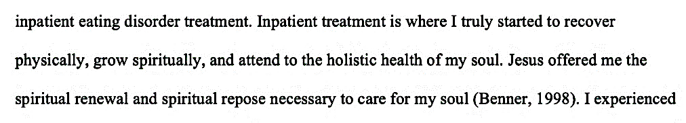

1. Referring to or quoting your own thought, concept, or idea from a prior paper you have written. Format such citations as unpublished manuscripts to avoid self-plagiarism.
2. Referring to or quoting scripture*.*

**Writing Center Resources**

Our writing resources are updated and refined often, and new ones are added periodically. We recommend you bookmark our [Resources page](https://www.studentlife.densem.edu/writing-center-resources) and refer to our APA resources while writing your papers.

We offer information on:

* [Writing with gender-inclusive language](https://www.studentlife.densem.edu/_files/ugd/abb5f7_98f6864394f54336a8ef142a287f1781.docx?dn=Gender-Inclusive%20Language%20-%202024.docx)
* [Avoiding plagiarism](https://www.studentlife.densem.edu/_files/ugd/abb5f7_75a26d50f495423ab5f29017538d70b6.docx?dn=Plagiarism%20-%20AI%20-%20examples.docx)
* [How to use copyrighted material](https://www.studentlife.densem.edu/_files/ugd/abb5f7_60fdd62e83b14aa0ab4e2dda77fb2315.docx?dn=Copyright%20Checklist.docx)

We also have the following resources, as well as many others, available to download:

|  |  |
| --- | --- |
| **APA Resources** |  |
| [APA formatting checklist](https://www.studentlife.densem.edu/_files/ugd/abb5f7_43cc5046548544229a461b7725a7c39f.docx?dn=APA%20Formatting%20Checklist.docx) | Refer to this list for basic APA formatting requirements. |
| [APA title page template](https://www.studentlife.densem.edu/_files/ugd/abb5f7_68928fbdd7c3491db84d9ff7fab2298f.docx?dn=APA%207th%20Title%20Page.docx) | Template for the title page with formatting notes. |
| [Citing Common Sources in APA](https://www.studentlife.densem.edu/_files/ugd/abb5f7_4b2f4a682f2d45e79b4c3508510b25cb.docx?dn=Sample%20Citations%20-%20APA%207th%20ed%20-%20Denver%20Seminary.docx) | Examples of parenthetical citations and reference entries from common sources. |
| [APA Sample Paper](https://www.studentlife.densem.edu/_files/ugd/abb5f7_e57db856ba4440208d072c69fcd255ec.pdf) | Example of a title page, three pages of text, and references, with formatting notes. |

Additional resources:

[Free Office 355 for Students](https://denverseminary.libguides.com/citations/Office365)

[Writing and Citing Webinars](https://denverseminary.libguides.com/citations/webinar)